Steps to create a Database Link from Oracle to MSSQL Server
https://dbsguru.com/steps-to-create-a-database-link-from-oracle-to-mssql-server/
https://www.youtube.com/watch?v=sD_ujAOalHs&ab_channel=DatabaseGuy
Below are the high-level steps we will follow to set up dblink.
1. Verify MSSQL Users access
2. Install MSSQL Server ODBC Drivers in Oracle Server
3. Edit the odbc.ini file & Test DSN’s connectivity in Oracle Server
4. Create initMSSQL.ora file in Oracle Server
5. Configure tnsname.ora & listener.ora file in Oracle Server
6. Create DB Link & Test Connectivity in Oracle Server
Below are setup details and the same will be used in this demonstration.
Sr. No. | Database | Version | Hostname | User | Port
1 | Oracle | 19.3 | test-machine01 |  | 1521
2 | MS-SQL SERVER | Standard Edition 2017 | MSSQLDBCS01 | test_readonly | 1433
Step 1. Verify MSSQL Users access: We already have a running default instance of MSSQL Server on Server: MSSQLDBCS01 on Default Port: 1433. Also User: test_readonly has already been created and has access to DB: [bidding db] on Table: users. You can verify this using utility sqlcmd.
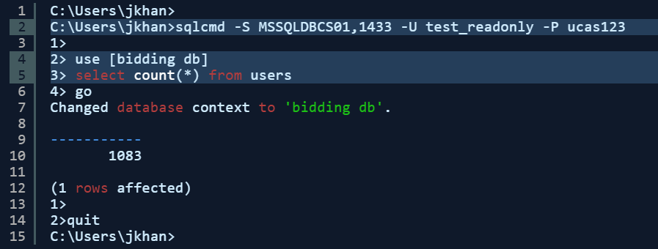
1  2  3  4  5  6  7  8  9  10  11  12  13  14  15 | C:\Users\jkhan>  C:\Users\jkhan>sqlcmd -S MSSQLDBCS01,1433 -U test_readonly -P ucas123  1>  2> use [bidding db]  3> select count(*) from users  4> go  Changed database context to 'bidding db'.  -----------  1083  (1 rows affected)  1>  2>quit  C:\Users\jkhan>
Step 2. Install MSSQL Server ODBC Drivers in Oracle Server: Verify that the file dg4odbc is present in your ORACLE_HOME environment. Import mssql yum repository using curl command as below. Once the repository is downloaded we can use commands like yum search, yum list, or yum whatprovides to verify required packages are available in the repository. Install packages msodbcsql17, mssql-tools, and unixODBC-devel using the below yum commands. Make sure file libmsodbcsql-17.so exist in location: /usr/lib64 after packages are installed.
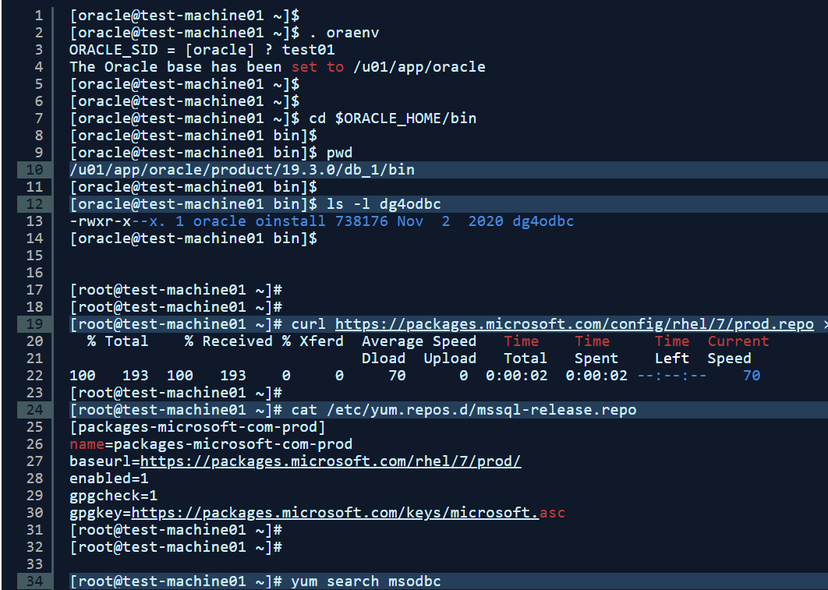
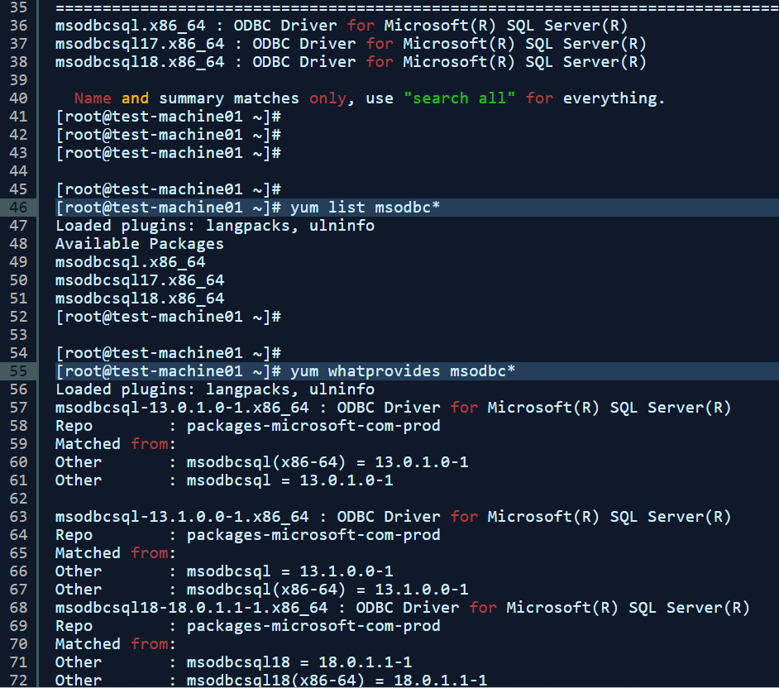
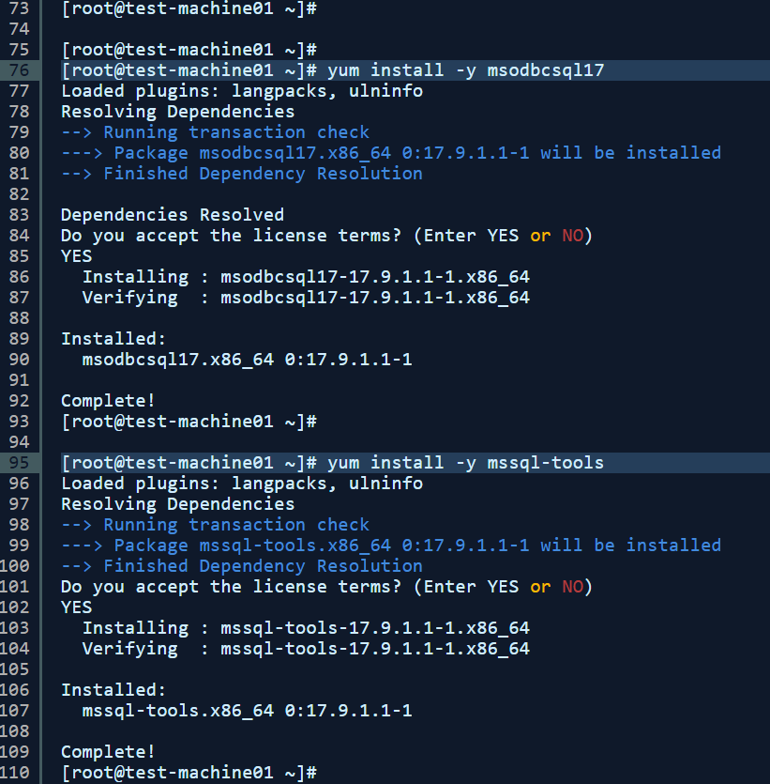
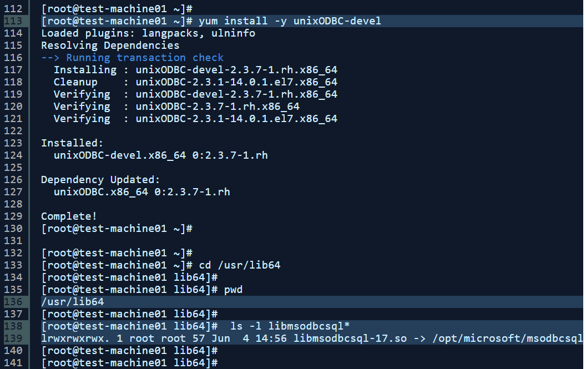

1  2  3  4  5  6  7  8  9  10  11  12  13  14  15  16  17  18  19  20  21  22  23  24  25  26  27  28  29  30  31  32  33  34  35  36  37  38  39  40  41  42  43  44  45  46  47  48  49  50  51  52  53  54  55  56  57  58  59  60  61  62  63  64  65  66  67  68  69  70  71  72  73  74  75  76  77  78  79  80  81  82  83  84  85  86  87  88  89  90  91  92  93  94  95  96  97  98  99  100  101  102  103  104  105  106  107  108  109  110  111  112  113  114  115  116  117  118  119  120  121  122  123  124  125  126  127  128  129  130  131  132  133  134  135  136  137  138  139  140  141 | [oracle@test-machine01 ~]$  [oracle@test-machine01 ~]$ . oraenv  ORACLE_SID = [oracle] ? test01  The Oracle base has been set to /u01/app/oracle  [oracle@test-machine01 ~]$  [oracle@test-machine01 ~]$  [oracle@test-machine01 ~]$ cd $ORACLE_HOME/bin  [oracle@test-machine01 bin]$  [oracle@test-machine01 bin]$ pwd  /u01/app/oracle/product/19.3.0/db_1/bin  [oracle@test-machine01 bin]$  [oracle@test-machine01 bin]$ ls -l dg4odbc  -rwxr-x--x. 1 oracle oinstall 738176 Nov 2 2020 dg4odbc  [oracle@test-machine01 bin]$  [root@test-machine01 ~]#  [root@test-machine01 ~]#  [root@test-machine01 ~]# curl https://packages.microsoft.com/config/rhel/7/prod.repo > /etc/yum.repos.d/mssql-release.repo  % Total % Received % Xferd Average Speed Time Time Time Current  Dload Upload Total Spent Left Speed  100 193 100 193 0 0 70 0 0:00:02 0:00:02 --:--:-- 70  [root@test-machine01 ~]#  [root@test-machine01 ~]# cat /etc/yum.repos.d/mssql-release.repo  [packages-microsoft-com-prod]  name=packages-microsoft-com-prod  baseurl=https://packages.microsoft.com/rhel/7/prod/  enabled=1  gpgcheck=1  gpgkey=https://packages.microsoft.com/keys/microsoft.asc  [root@test-machine01 ~]#  [root@test-machine01 ~]#  [root@test-machine01 ~]# yum search msodbc  ==================================================================================== N/S matched: msodbc =====================================================================================  msodbcsql.x86_64 : ODBC Driver for Microsoft(R) SQL Server(R)  msodbcsql17.x86_64 : ODBC Driver for Microsoft(R) SQL Server(R)  msodbcsql18.x86_64 : ODBC Driver for Microsoft(R) SQL Server(R)  Name and summary matches only, use "search all" for everything.  [root@test-machine01 ~]#  [root@test-machine01 ~]#  [root@test-machine01 ~]#  [root@test-machine01 ~]#  [root@test-machine01 ~]# yum list msodbc*  Loaded plugins: langpacks, ulninfo  Available Packages  msodbcsql.x86_64 13.1.9.2-1 packages-microsoft-com-prod  msodbcsql17.x86_64 17.9.1.1-1 packages-microsoft-com-prod  msodbcsql18.x86_64 18.0.1.1-1 packages-microsoft-com-prod  [root@test-machine01 ~]#  [root@test-machine01 ~]#  [root@test-machine01 ~]# yum whatprovides msodbc*  Loaded plugins: langpacks, ulninfo  msodbcsql-13.0.1.0-1.x86_64 : ODBC Driver for Microsoft(R) SQL Server(R)  Repo : packages-microsoft-com-prod  Matched from:  Other : msodbcsql(x86-64) = 13.0.1.0-1  Other : msodbcsql = 13.0.1.0-1  msodbcsql-13.1.0.0-1.x86_64 : ODBC Driver for Microsoft(R) SQL Server(R)  Repo : packages-microsoft-com-prod  Matched from:  Other : msodbcsql = 13.1.0.0-1  Other : msodbcsql(x86-64) = 13.1.0.0-1  msodbcsql18-18.0.1.1-1.x86_64 : ODBC Driver for Microsoft(R) SQL Server(R)  Repo : packages-microsoft-com-prod  Matched from:  Other : msodbcsql18 = 18.0.1.1-1  Other : msodbcsql18(x86-64) = 18.0.1.1-1  [root@test-machine01 ~]#  [root@test-machine01 ~]#  [root@test-machine01 ~]# sudo ACCEPT_EULA=Y yum install -y msodbcsql17  Loaded plugins: langpacks, ulninfo  Resolving Dependencies  --> Running transaction check  ---> Package msodbcsql17.x86_64 0:17.9.1.1-1 will be installed  --> Finished Dependency Resolution  Dependencies Resolved  Do you accept the license terms? (Enter YES or NO)  YES  Installing : msodbcsql17-17.9.1.1-1.x86_64 1/1  Verifying : msodbcsql17-17.9.1.1-1.x86_64 1/1  Installed:  msodbcsql17.x86_64 0:17.9.1.1-1  Complete!  [root@test-machine01 ~]#  [root@test-machine01 ~]# yum install -y mssql-tools  Loaded plugins: langpacks, ulninfo  Resolving Dependencies  --> Running transaction check  ---> Package mssql-tools.x86_64 0:17.9.1.1-1 will be installed  --> Finished Dependency Resolution  Do you accept the license terms? (Enter YES or NO)  YES  Installing : mssql-tools-17.9.1.1-1.x86_64 1/1  Verifying : mssql-tools-17.9.1.1-1.x86_64 1/1  Installed:  mssql-tools.x86_64 0:17.9.1.1-1  Complete!  [root@test-machine01 ~]#  [root@test-machine01 ~]#  [root@test-machine01 ~]# yum install -y unixODBC-devel  Loaded plugins: langpacks, ulninfo  Resolving Dependencies  --> Running transaction check  Installing : unixODBC-devel-2.3.7-1.rh.x86_64 2/3  Cleanup : unixODBC-2.3.1-14.0.1.el7.x86_64 3/3  Verifying : unixODBC-devel-2.3.7-1.rh.x86_64 1/3  Verifying : unixODBC-2.3.7-1.rh.x86_64 2/3  Verifying : unixODBC-2.3.1-14.0.1.el7.x86_64 3/3  Installed:  unixODBC-devel.x86_64 0:2.3.7-1.rh  Dependency Updated:  unixODBC.x86_64 0:2.3.7-1.rh  Complete!  [root@test-machine01 ~]#  [root@test-machine01 ~]#  [root@test-machine01 ~]# cd /usr/lib64  [root@test-machine01 lib64]#  [root@test-machine01 lib64]# pwd  /usr/lib64  [root@test-machine01 lib64]#  [root@test-machine01 lib64]# ls -l libmsodbcsql*  lrwxrwxrwx. 1 root root 57 Jun 4 14:56 libmsodbcsql-17.so -> /opt/microsoft/msodbcsql17/lib64/libmsodbcsql-17.9.so.1.1  [root@test-machine01 lib64]#  [root@test-machine01 lib64]#
Step 3. Edit odbc.ini file & Test DSN’s connectivity in Oracle Server: Edit the odbc files and fill MSSQL Server details under the [MSSQL] header. This header name we will use in the next steps. We can use tools like sqlcmd & isql received from package mssql-tools to test our DSN (Domain Source Name) connectivity. As per the below test connectivity is failed we can use tools like nc in Linux to check if SQL Server Port 1433 is reachable from the Linux server. We need to make sure Port 1433 is open in the firewall. Involve System and Network Admin to get it done.
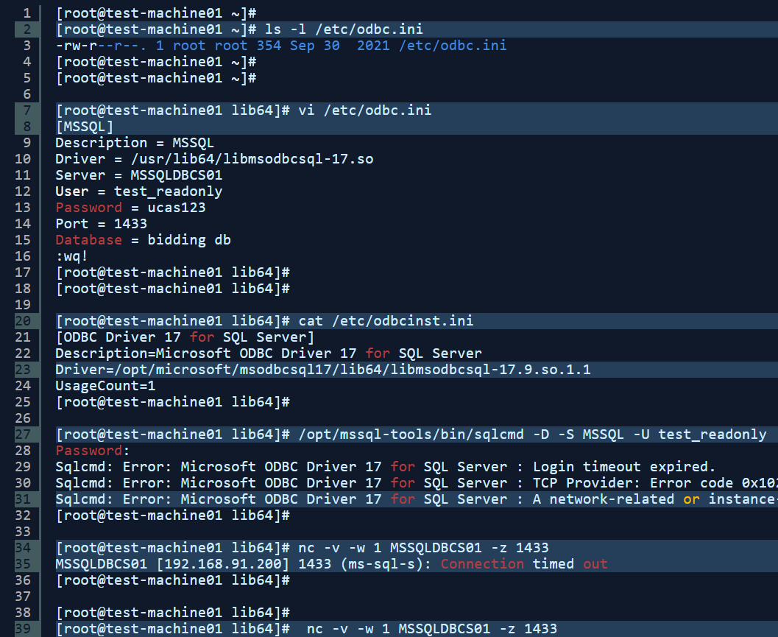
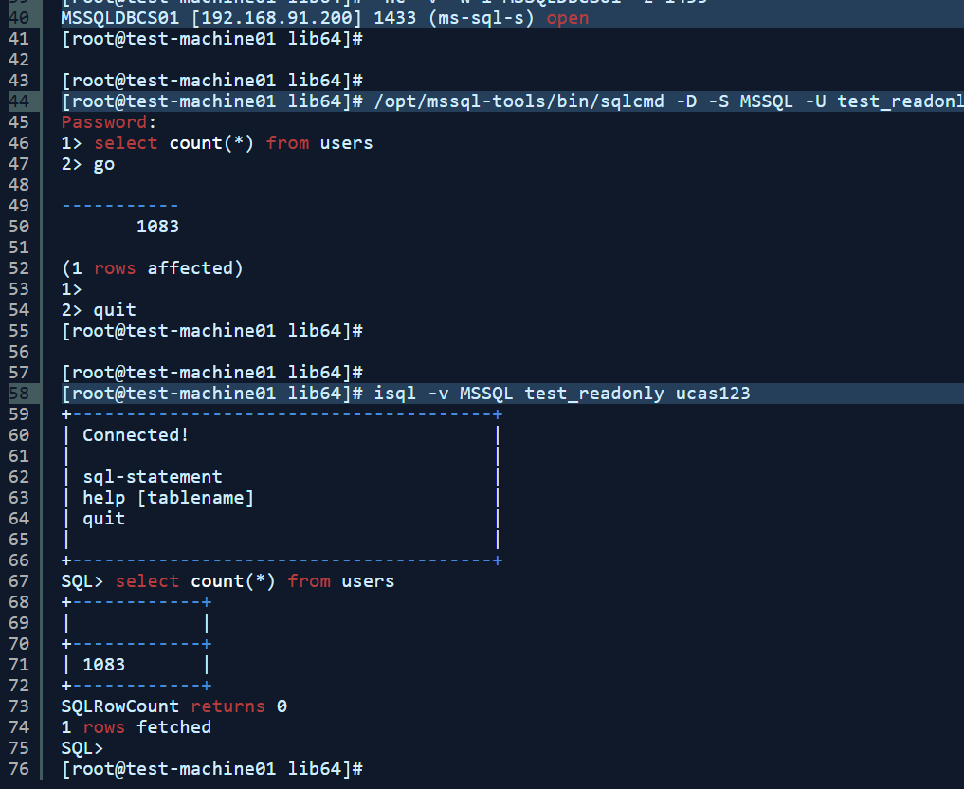

1  2  3  4  5  6  7  8  9  10  11  12  13  14  15  16  17  18  19  20  21  22  23  24  25  26  27  28  29  30  31  32  33  34  35  36  37  38  39  40  41  42  43  44  45  46  47  48  49  50  51  52  53  54  55  56  57  58  59  60  61  62  63  64  65  66  67  68  69  70  71  72  73  74  75  76 | [root@test-machine01 ~]#  [root@test-machine01 ~]# ls -l /etc/odbc.ini  -rw-r--r--. 1 root root 354 Sep 30 2021 /etc/odbc.ini  [root@test-machine01 ~]#  [root@test-machine01 ~]#  [root@test-machine01 lib64]# vi /etc/odbc.ini  [MSSQL]  Description = MSSQL  Driver = /usr/lib64/libmsodbcsql-17.so  Server = MSSQLDBCS01  User = test_readonly  Password = ucas123  Port = 1433  Database = bidding db  :wq!  [root@test-machine01 lib64]#  [root@test-machine01 lib64]#  [root@test-machine01 lib64]# cat /etc/odbcinst.ini  [ODBC Driver 17 for SQL Server]  Description=Microsoft ODBC Driver 17 for SQL Server  Driver=/opt/microsoft/msodbcsql17/lib64/libmsodbcsql-17.9.so.1.1  UsageCount=1  [root@test-machine01 lib64]#  [root@test-machine01 lib64]# /opt/mssql-tools/bin/sqlcmd -D -S MSSQL -U test_readonly  Password:  Sqlcmd: Error: Microsoft ODBC Driver 17 for SQL Server : Login timeout expired.  Sqlcmd: Error: Microsoft ODBC Driver 17 for SQL Server : TCP Provider: Error code 0x102.  Sqlcmd: Error: Microsoft ODBC Driver 17 for SQL Server : A network-related or instance-specific error has occurred while establishing a connection to SQL Server. Server is not found or not accessible. Check if instance name is correct and if SQL Server is configured to allow remote connections. For more information see SQL Server Books Online..  [root@test-machine01 lib64]#  [root@test-machine01 lib64]# nc -v -w 1 MSSQLDBCS01 -z 1433  MSSQLDBCS01 [192.168.91.200] 1433 (ms-sql-s): Connection timed out  [root@test-machine01 lib64]#  [root@test-machine01 lib64]#  [root@test-machine01 lib64]# nc -v -w 1 MSSQLDBCS01 -z 1433  MSSQLDBCS01 [192.168.91.200] 1433 (ms-sql-s) open  [root@test-machine01 lib64]#  [root@test-machine01 lib64]#  [root@test-machine01 lib64]# /opt/mssql-tools/bin/sqlcmd -D -S MSSQL -U test_readonly  Password:  1> select count(*) from users  2> go  -----------  1083  (1 rows affected)  1>  2> quit  [root@test-machine01 lib64]#  [root@test-machine01 lib64]#  [root@test-machine01 lib64]# isql -v MSSQL test_readonly ucas123  +---------------------------------------+  | Connected! |  | |  | sql-statement |  | help [tablename] |  | quit |  | |  +---------------------------------------+  SQL> select count(*) from users  +------------+  | |  +------------+  | 1083 |  +------------+  SQLRowCount returns 0  1 rows fetched  SQL>  [root@test-machine01 lib64]#
Step 4. Create initMSSQL.ora file in Oracle Server: Create file initMSSQL.ora under directory $ORACLE_HOME/hs/admin and add the below parameters. Please note we are using MSSQL as our SID name and in the parameter, HS_FDS_CONNECT_INFO = MSSQL is the same header we use in the file: odbc.ini.
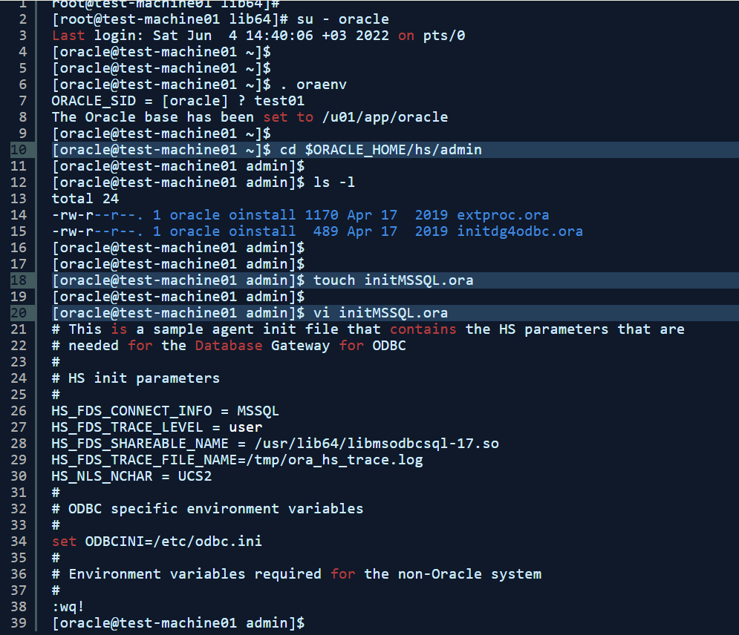

1  2  3  4  5  6  7  8  9  10  11  12  13  14  15  16  17  18  19  20  21  22  23  24  25  26  27  28  29  30  31  32  33  34  35  36  37  38  39 | root@test-machine01 lib64]#  [root@test-machine01 lib64]# su - oracle  Last login: Sat Jun 4 14:40:06 +03 2022 on pts/0  [oracle@test-machine01 ~]$  [oracle@test-machine01 ~]$  [oracle@test-machine01 ~]$ . oraenv  ORACLE_SID = [oracle] ? test01  The Oracle base has been set to /u01/app/oracle  [oracle@test-machine01 ~]$  [oracle@test-machine01 ~]$ cd $ORACLE_HOME/hs/admin  [oracle@test-machine01 admin]$  [oracle@test-machine01 admin]$ ls -l  total 24  -rw-r--r--. 1 oracle oinstall 1170 Apr 17 2019 extproc.ora  -rw-r--r--. 1 oracle oinstall 489 Apr 17 2019 initdg4odbc.ora  [oracle@test-machine01 admin]$  [oracle@test-machine01 admin]$  [oracle@test-machine01 admin]$ touch initMSSQL.ora  [oracle@test-machine01 admin]$  [oracle@test-machine01 admin]$ vi initMSSQL.ora  # This is a sample agent init file that contains the HS parameters that are  # needed for the Database Gateway for ODBC  #  # HS init parameters  #  HS_FDS_CONNECT_INFO = MSSQL  HS_FDS_TRACE_LEVEL = user  HS_FDS_SHAREABLE_NAME = /usr/lib64/libmsodbcsql-17.so  HS_FDS_TRACE_FILE_NAME=/tmp/ora_hs_trace.log  HS_NLS_NCHAR = UCS2  #  # ODBC specific environment variables  #  set ODBCINI=/etc/odbc.ini  #  # Environment variables required for the non-Oracle system  #  :wq!  [oracle@test-machine01 admin]$
Step 5. Configure tnsname.ora & listener.ora file in Oracle Server: Configure tnsnames.ora & listener.ora same as below. Please note here SID = MSSQL is the SID name we created in Step 4. Once listener file changes are done reload the listener using the below command. Add tnsentry MSSQL in tnsnames.ora file or any other tnsname we will use this tnsname during dblink creation.
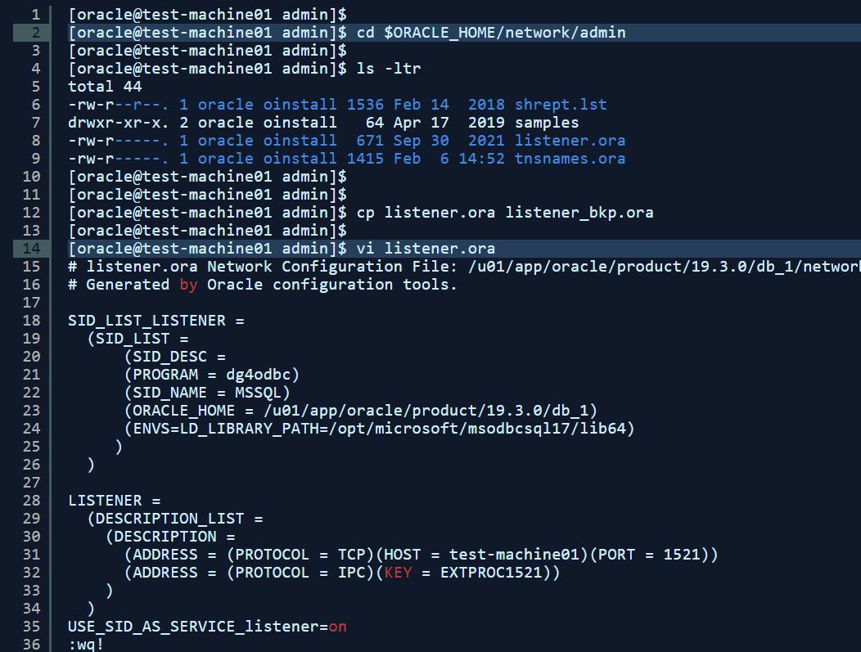
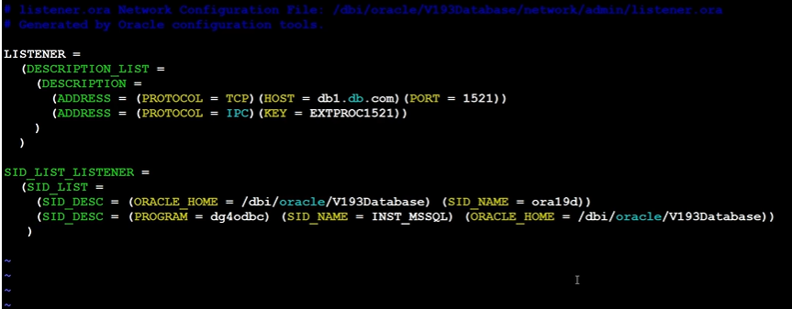
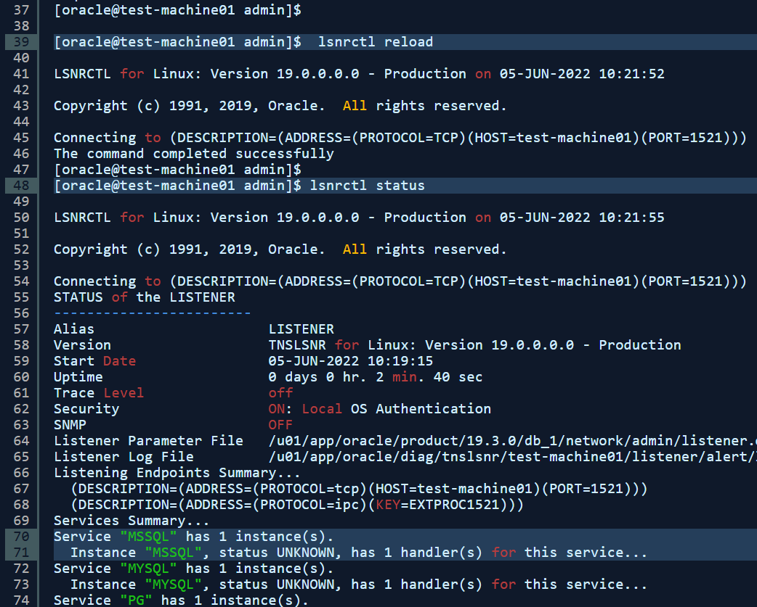
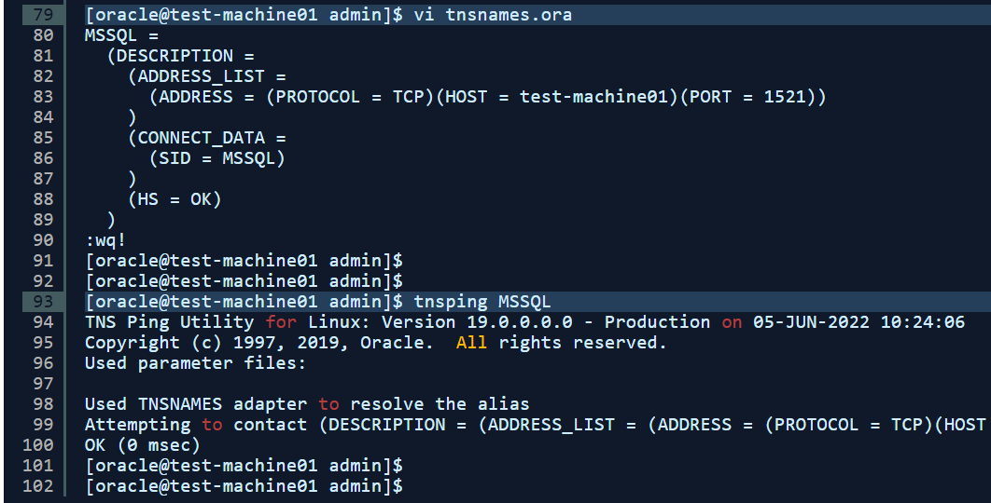

1  2  3  4  5  6  7  8  9  10  11  12  13  14  15  16  17  18  19  20  21  22  23  24  25  26  27  28  29  30  31  32  33  34  35  36  37  38  39  40  41  42  43  44  45  46  47  48  49  50  51  52  53  54  55  56  57  58  59  60  61  62  63  64  65  66  67  68  69  70  71  72  73  74  75  76  77  78  79  80  81  82  83  84  85  86  87  88  89  90  91  92  93  94  95  96  97  98  99  100  101  102 | [oracle@test-machine01 admin]$  [oracle@test-machine01 admin]$ cd $ORACLE_HOME/network/admin  [oracle@test-machine01 admin]$  [oracle@test-machine01 admin]$ ls -ltr  total 44  -rw-r--r--. 1 oracle oinstall 1536 Feb 14 2018 shrept.lst  drwxr-xr-x. 2 oracle oinstall 64 Apr 17 2019 samples  -rw-r-----. 1 oracle oinstall 671 Sep 30 2021 listener.ora  -rw-r-----. 1 oracle oinstall 1415 Feb 6 14:52 tnsnames.ora  [oracle@test-machine01 admin]$  [oracle@test-machine01 admin]$  [oracle@test-machine01 admin]$ cp listener.ora listener_bkp.ora  [oracle@test-machine01 admin]$  [oracle@test-machine01 admin]$ vi listener.ora  # listener.ora Network Configuration File: /u01/app/oracle/product/19.3.0/db_1/network/admin/listener.ora  # Generated by Oracle configuration tools.  SID_LIST_LISTENER =  (SID_LIST =  (SID_DESC =  (PROGRAM = dg4odbc)  (SID_NAME = MSSQL)  (ORACLE_HOME = /u01/app/oracle/product/19.3.0/db_1)  (ENVS=LD_LIBRARY_PATH=/opt/microsoft/msodbcsql17/lib64)  )  )  LISTENER =  (DESCRIPTION_LIST =  (DESCRIPTION =  (ADDRESS = (PROTOCOL = TCP)(HOST = test-machine01)(PORT = 1521))  (ADDRESS = (PROTOCOL = IPC)(KEY = EXTPROC1521))  )  )  USE_SID_AS_SERVICE_listener=on  :wq!  [oracle@test-machine01 admin]$  [oracle@test-machine01 admin]$ lsnrctl reload  LSNRCTL for Linux: Version 19.0.0.0.0 - Production on 05-JUN-2022 10:21:52  Copyright (c) 1991, 2019, Oracle. All rights reserved.  Connecting to (DESCRIPTION=(ADDRESS=(PROTOCOL=TCP)(HOST=test-machine01)(PORT=1521)))  The command completed successfully  [oracle@test-machine01 admin]$  [oracle@test-machine01 admin]$ lsnrctl status  LSNRCTL for Linux: Version 19.0.0.0.0 - Production on 05-JUN-2022 10:21:55  Copyright (c) 1991, 2019, Oracle. All rights reserved.  Connecting to (DESCRIPTION=(ADDRESS=(PROTOCOL=TCP)(HOST=test-machine01)(PORT=1521)))  STATUS of the LISTENER  ------------------------  Alias LISTENER  Version TNSLSNR for Linux: Version 19.0.0.0.0 - Production  Start Date 05-JUN-2022 10:19:15  Uptime 0 days 0 hr. 2 min. 40 sec  Trace Level off  Security ON: Local OS Authentication  SNMP OFF  Listener Parameter File /u01/app/oracle/product/19.3.0/db_1/network/admin/listener.ora  Listener Log File /u01/app/oracle/diag/tnslsnr/test-machine01/listener/alert/log.xml  Listening Endpoints Summary...  (DESCRIPTION=(ADDRESS=(PROTOCOL=tcp)(HOST=test-machine01)(PORT=1521)))  (DESCRIPTION=(ADDRESS=(PROTOCOL=ipc)(KEY=EXTPROC1521)))  Services Summary...  Service "MSSQL" has 1 instance(s).  Instance "MSSQL", status UNKNOWN, has 1 handler(s) for this service...  Service "MYSQL" has 1 instance(s).  Instance "MYSQL", status UNKNOWN, has 1 handler(s) for this service...  Service "PG" has 1 instance(s).  Instance "PG", status UNKNOWN, has 1 handler(s) for this service...  The command completed successfully  [oracle@test-machine01 admin]$  [oracle@test-machine01 admin]$ vi tnsnames.ora  MSSQL =  (DESCRIPTION =  (ADDRESS_LIST =  (ADDRESS = (PROTOCOL = TCP)(HOST = test-machine01)(PORT = 1521))  )  (CONNECT_DATA =  (SID = MSSQL)  )  (HS = OK)  )  :wq!  [oracle@test-machine01 admin]$  [oracle@test-machine01 admin]$  [oracle@test-machine01 admin]$ tnsping MSSQL  TNS Ping Utility for Linux: Version 19.0.0.0.0 - Production on 05-JUN-2022 10:24:06  Copyright (c) 1997, 2019, Oracle. All rights reserved.  Used parameter files:  Used TNSNAMES adapter to resolve the alias  Attempting to contact (DESCRIPTION = (ADDRESS_LIST = (ADDRESS = (PROTOCOL = TCP)(HOST = test-machine01)(PORT = 1521))) (CONNECT_DATA = (SID = MSSQL)) (HS = OK))  OK (0 msec)  [oracle@test-machine01 admin]$  [oracle@test-machine01 admin]$
Step 6. Create DB Link & Test Connectivity in Oracle Server: Once all the above steps are done login to Oracle DB and create dblink using the same SQLServer username test_readonly and tnsname MSSQL. Once DBLink is created try to access the MSSQL Server table: users.

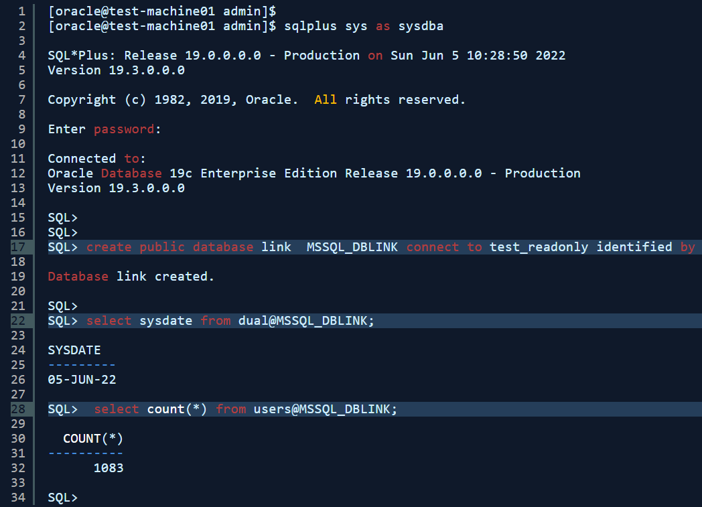

1  2  3  4  5  6  7  8  9  10  11  12  13  14  15  16  17  18  19  20  21  22  23  24  25  26  27  28  29  30  31  32  33  34 | [oracle@test-machine01 admin]$  [oracle@test-machine01 admin]$ sqlplus sys as sysdba  SQL*Plus: Release 19.0.0.0.0 - Production on Sun Jun 5 10:28:50 2022  Version 19.3.0.0.0  Copyright (c) 1982, 2019, Oracle. All rights reserved.  Enter password:  Connected to:  Oracle Database 19c Enterprise Edition Release 19.0.0.0.0 - Production  Version 19.3.0.0.0  SQL>  SQL>  SQL> create public database link MSSQL_DBLINK connect to test_readonly identified by ucas123 using 'MSSQL';  Database link created.  SQL>  SQL> select sysdate from dual@MSSQL_DBLINK;  SYSDATE  ---------  05-JUN-22  SQL> select count(*) from users@MSSQL_DBLINK;  COUNT(*)  ----------  1083

